SUBJECT: DESIGN AND TECHNOLOGY CLASS:…… … DATE:……/……./20…. DURATION:………….

BOYS:…………………… GIRLS ………………………………………. TOTAL OF PUPILS…
TOPIC: ELECTRICAL PRINCIPLES SUBTOPIC: INDUSTRIAL POWER AND CONTROL CIRCUITS

LEARNING OUTCOMES LSBAT
- Identify and explain two types of circuits.
- Identifying and Explain symbols for Contactors, Overloads, Push buttons, Timers Indicator, lamps, Bells, sirens

RATIONALE
Knowledge: Symbols and uses of Contactors, Overloads, Push buttons, Timers Indicator, lamps, Bells, sirens Interpret
Skills: Interpretation of symbols in circuits, Application of symbols in drawing circuits
Values: Awareness of conventional symbols, Curiosity in learning about symbols used in circuits
TEACHING AIDS
……………………………………………………………………………………………………………………………………………

PART | LESSON CONTENT | METHOD OLOGY | LEARNER ACTIVITY
introdu ction | - Recap on the previous lesson | Questions and answers | Provide answers
Development | TWO TYPE OF CIRCUITS  Motor has two circuits: the powercircuit and the control circuits  - Power circuit runs from the power supply to the motor  - The control circuit operates the opening and closing of a contactor.  ELECTRICAL COMPONENTS  Overload relay  - An overload is a protective device that protects against excess current due to overloading, short circuits and earth fault  Contactors coil,  - A contactor is an electrically-controlled switch used for switching an electrical power circuit.  Push buttons, (start push button and stop push button)  Timers Indicator, (TDOE on or (TDOD off)  - A timer is a device that is used to count (or measure) the time required for a particular process or operation to take place,  Circuit breaker  - Makes and breaks a circuit under abnormal or normal conditions. It is designed to protect the motor against current higher than the motor is designed for.  Interlocking system  - This is a protective system of switching which prevents two or more control circuits from operating at the same time.  Isolator  - Mechanical switch which isolates a part of circuit from system as when required. Electrical isolators separate a part of the system from rest for safe maintenance work.  Lamps, Bells, Sirens | Questions And Answers  Demonstra tion  V/E | Taking note of important points  Provide answers
Application | CLASS EXERCISE  - Identify and explain two types of circuits.  - Write the symbols for following electrical components  - Contactors,  - Overloads,  - Start and stop Push buttons,  - Timers Indicator,  - Explain the uses for  - Contactors,  - Overloads,  - Start and stop Push buttons, | Questions And Answers | Provide answers
Conclu sion | - Recap on the main steps and points | V/E

LESSON EVALUATION

SUBJECT: DESIGN AND TECHNOLOGY CLASS:…… … DATE:……/……./20…. DURATION:………….

BOYS:…………………… GIRLS ………………………………………. TOTAL OF PUPILS…
TOPIC: ELECTRICAL PRINCIPLES SUBTOPIC: READ CONTROL AND POWER CIRCUITS

LEARNING OUTCOMES LSBAT:
- Read and Interpret simple and complex circuits
- Install direct on line circuits

RATIONALE
Knowledge: Interpret Control circuit, Power circuit Connect the motor in star/delta, Control circuit,
Skills: Application of wiring techniques when making installations,
Values: Awareness of making direct on line installations, Inquisitiveness when making installations.

TEACHING AIDS
PART | LESSON CONTENT | METHODO LOGY | LEARNER ACTIVITY
Introdu ction | - Recap on the previous lesson | Q/A | Provide answers
Develo pment | ELECTRICAL MOTOR INSTALLATION  Safety procedures  - Check that gears, belts, driven machinery, etc., are covered by suitable Protective guards to prevent injury to anyone nearby  Location:  - Always try to locate the motor in a clean, dry, cool location.  - Suitable insulation of motor leads must be provided where dripping or spraying oil, water, or other hazardous liquids may occur, unless the motor is specially designed for these conditions.  Foundation  - A rigid foundation is essential for minimum vibration and proper alignment between motor and load.  - Concrete, reinforced as necessary or required makes the best foundation particular for large motors and driven loads  THREE PHASE MOTORS STARTERS  - Direct on Line Motor Starter  - Star delta starter  - Auto transformer  Direct on Line Motor Starter  - DOL is the simplest way to start induction motor. Full voltage is applied directly to the stator winding of a stationary motor.  Explanation of DOL operation  - Refer to the power and control circuit diagrams  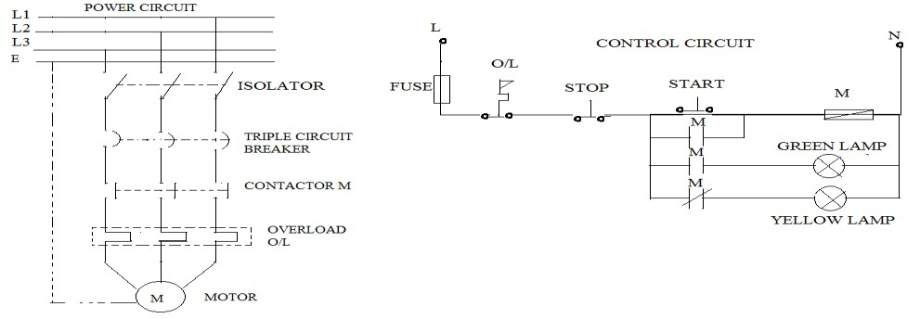  - when the isolator and triple pole MCB are closed a yellow indicator lamp comes on  - When the start push button is pressed, a current flows in the order Fuse-O/L-Stop – Start-Coin M-N, thereby exciting contactor Coin M.  - When the contactor coil M gets energised the hold on contact M closes, the 3 phase induction motor starts running, the yellow indicator lamp goes off and a green lamp come on due to closing of contact M.  - The induction motor will continue running until the Stop P.B is pressed or overload occurs thereby causing the motor to stop running, and the green lamp goes off, yellow lamp comes ON
Applica tion | CLASS EXERCISE/HOMEWORK  Design both power and control circuit to conform the given information | Q/A | Provide answers
Conclus ion | - Recap on the main points | V/E
LESSON EVALUATION

TEACHER:MWALE CHIPO

DESIGN AND TECHNOLOGY DEPARTMENT LESSON PLAN

SUBJECT: DESIGN AND TECHNOLOGY CLASS:…… … DATE:……/……./20…. DURATION:………….
BOYS:…………………… GIRLS ………………………………………. TOTAL OF PUPILS… TOPIC: ELECTRICAL MACHINES SUBTOPIC: DC MACHINES LEARNING OUTCOMES LSBAT
- Define electrical machine
- State three categories of electrical machine
- Explain constructional of a simple four pole DC machine

RATIONALE
Knowledge: Construction, Generator action, emf equation,
Skills: Identification of physical features of d c generators
Values: Observation of safety precautions when operating d c generators

TEACHING AIDS
PART | LESSON CONTENT | METHOD OLOGY | LEARNER ACTIVITY
Introdu ction | - Recap on the previous lesson | Q/A | Provide answers
Development | ELECTRICAL MACHINE  - Electrical Machine is a device that converts energy  CATEGORIES OF ELECTRICAL MACHINE  - Motor which convert electrical energy to mechanical energy  - Generator which convert mechanical energy to electrical energy  - Transformer which change the voltage level of an alternating current  DC MACHINES  - Electromechanical energy converters which work from a DC source and generate mechanical power or  - convert mechanical power into DC power  CONSTRUCTIONAL DETAILS OF A SIMPLE FOUR-POLE DC MACHINE  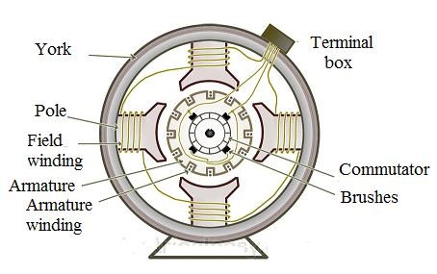  - Yoke:  - This is the outer frame of a dc machine  - It is made up of cast iron or steel.  - It is also carries the magnetic flux produced by the field winding.  - Poles and pole shoes:  - Poles are joined to the yoke with the help of bolts or welding.  - They carry field winding and pole shoes are fastened to them.  - Pole shoes serve two purposes; (i) they support field coils and (ii) spread out the flux in air gap uniformly.  - Field winding:  - A field winding is the insulated current-carrying coils on a field magnet that produce the magnetic field needed to excite a generator or motor.  - They are usually made of copper aand they are connected in series  - When energized, they form alternate North and South poles.  - Armature core:  - Armature core is the rotor of a dc machine. It is cylindrical in shape with slots to carry armature winding.  - Made of thin laminated circular steel disks for reducing eddy current losses.  - Armature winding:  i. Armature winding is the main current-carrying winding in which the electromotive force or counter-emf of rotation is induced.  - Commutator and brushes:  - In dc generator, is to collect the current generated in armature conductors.  - In a dc motor, commutator helps in providing current to the armature conductors.
Applicat ion | CLASS EXERCISE  - Define electrical machine  - State three categories of electrical machine  - Explain constructional of a simple four pole DC machine | Questions And Answers | Provide answers
Conclus ion | - Recap on the main steps and points | V/E

TEACHER:MWALE CHIPO

DESIGN AND TECHNOLOGY DEPARTMENT

LESSON PLAN

SUBJECT: DESIGN AND TECHNOLOGY CLASS:…… … DATE:……/……./20…. DURATION:………….
BOYS:…………………… GIRLS ………………………………………. TOTAL OF PUPILS… TOPIC: ELECTRICAL MACHINES SUBTOPIC: DC GENERATOR LEARNING OUTCOMES LSBAT
- Explain DC generators
- Identify types of DC generator

RATIONALE
Knowledge: Types of D.C generators: Series, shunt and Compound
Skills: Identification of physical features of d c generators
Values: Observation of safety precautions when operating d c generators
TEACHING AIDS
……………………………………………………………………………………………………………………………………………

PART | LESSON CONTENT | METHOD OLOGY | LEARNER ACTIVITY
introdu ction | - Recap on the previous lesson | Questions and answers | Provide answers
Development | DC GENERATOR  - An electrical machine which converts mechanical energy into DC electricity.  - This energy conversion is based on the principle of production of dynamic induced electromotive force  WORKING PRINCIPLE OF DC GENERATOR.  - When a conductor moves in a magnetic field, an emf is induced across the conductor  TYPES OF A DC GENERATOR:  - Separately excited: field magnetics are energized by some external DC source such as battery.  - Permanent magnet: this is where the flux in the magnetic circuit is established by permanent magnet  - Self-excited. Field magnetic are energized by the current produced by the generator itself.  CLASSIFICATION OF SELF EXCITED DC GENERATORS  - Series wound - field winding are connected in series with armature winding/conductors  - Shunt wound - field winding in parallel with armature winding  - Compound wound - combination of series and shunt winding
Applicati on | CLASS EXERCISE  - Define DC generator  - State and explain different types of generators | Questions And Answers | Provide answers
Conclu sion | - Recap on the main steps and points | V/E
LESSON EVALUATION

TEACHER:MWALE CHIPO

DESIGN AND TECHNOLOGY DEPARTMENT

LESSON PLAN

SUBJECT: DESIGN AND TECHNOLOGY CLASS:…… … DATE:……/……./20…. DURATION:……

BOYS:…………………… GIRLS ………………………………………. TOTAL OF PUPILS…
TOPIC: ELECTRICAL MACHINES SUBTOPIC: SYNCHRONOUS MOTORS AND GENERATORS

LEARNING OUTCOMES LSBAT

Explain synchronous motors and generators
- Describe the Construction of synchronous motors and generator
- Describe principle of operation generator
- State the main characteristic of synchronous motor and methods of starting
RATIONALE
Knowledge: Methods of starting, application of synchronous motors, Skills: Identification and Application of synchronous motors in power Values: Awareness of operations of synchronous motors and generator

TEACHING AIDS
PART | LESSON CONTENT | METHO DOLOG Y | LEARNER ACTIVITY
Introd uction | - Recap on the previous lesson | Q/A | Provide answers
Development | SYNCHRONOUS MOTORS AND GENERATORS  - Synchronous Motors (doubly excited motor) is a machine that covert AC electric power to mechanical power at a constant speed called its synchronous speed.  - When mechanical energy is applied to the machine it operate as synchronous Generators  - When electrial enery is applied to the machine it operates as synchronous motor CONSTRUCTION OF SYNCHRONOUS MOTORS AND GENERATOR  - Stator (stationary part) which house the three stator armature winding  - Rotor (rotating part). Two types of rotor Salient pole rotors used for low speeds and cylindrical rotors used for high speeds  - a synchronous motors is a doubly excited machine- its armature is energised from an AC source and its field winding from a DC source  PRINCIPLE OF OPERATION GENERATOR  - The rotor of the generator is driven by a prime-mover  - A dc current is flowing in the rotor winding which produces a rotating magnetic field within the machine  - The rotating magnetic field induces a three-phase voltage in the stator winding of the generator  - When a three phase-supply is given to the stator of the synchronous motor, it produces a rotating magnetic flux of constant magnitude, rotating at synchronous speed.  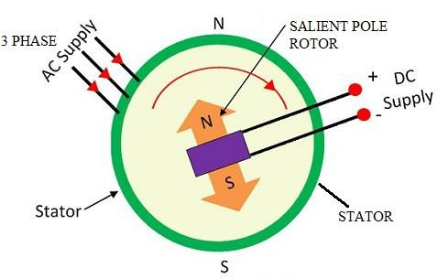  MAIN CHARACTERISTIC OF SYNCHRONOUS MOTOR  - They run either at synchronous motors speed or not at all  - They are not self- starting  - They can be operated under a wide range of power factors, both lagging and leading  METHODS OF STARTING  - With the help of an external prime mover With the help of damper windings
Applica tion | CLASS EXERCISE  - State the main characteristic of synchronous motor,  - State two methods of starting  - Principle of operation Generator | Questions And Answers | Provide answers
Conclu sion | - Recap on the main steps and points | V/E
LESSON EVALUATION

TEACHER:MWALE CHIPO

DESIGN AND TECHNOLOGY DEPARTMENT LESSON PLAN

SUBJECT: DESIGN AND TECHNOLOGY CLASS:…… … DATE:……/……./20…. DURATION:………….

BOYS:…………………… GIRLS ………………………………………. TOTAL OF PUPILS…
TOPIC: ELECTRICAL MACHINES SUBTOPIC: SYNCHRONOUS MOTORS AND GENERATORS

LEARNING OUTCOMES LSBAT
- Explain types of synchronous motors
- State application of synchronous motors
- Explain the maintenance of induction motor
- Mention the most common motor faults

RATIONALE
Knowledge: application of synchronous motors, maintenance of induction motor, most common motor faults
Skills: Identification and Application of synchronous motors in power
Values: Awareness of operations of synchronous motors and generator

TEACHING AIDS
PART | LESSON CONTENT | METHO DOLOG Y | LEARNER ACTIVITY
Introd uction | - Recap on the previous lesson | Q/A | Provide answers
Development | SYNCHRONOUS MOTORS AND GENERATORS TYPES OF SYNCHRONOUS MOTORS  - Non-excited motors. These motors employ a self-starting circuit and require no external excitation supply.  - Direct-current excited. The direct current can be supplied from a separate source or from a dc generator directly connected to the motor shaft  TYPES OF SYNCHRONOUS GENERATOR  - Single phase  - 3 phase  APPLICATION OF SYNCHRONOUS MOTORS  - They are used for power factor improvement in heavy industry and electrical submission  - They are used to control the voltage at the end of transmission lines by varying their excitation  - They are used in textile mills, cements factories, mining industries etc for power applications  DIFFERENT TORQUES OF A SYNCHRONOUS MOTOR  - Starting /breakaway torque – turning effect developed by motor when full voltage is applied to its stator (armature) winding  - Running torque- torque developed by the motor under running condition. T is determined by the horsepower and speed of the driven machine  - Pull-in torque- is a maximum value of torque which allows a synchronous motor to remain in synchronism without “pulling out” of step or synchronism  - Pull-out torque- is the maximum torque the motor can produce at full rated voltage and frequency.  MAINTENANCE OF INDUCTION MOTOR  - The insulation of the stator winding should be inspected from time to time for signs of deterioration  - The insulation resistance between the stator windings and each should be tested periodically using the megger  - The bearings of the motor require to be lubricated from time to time with grease or oil  - Check air gap.  - Clean motor thoroughly, blowing out dirt from windings, and wipe commutator and brushes  - Check brushes and replace any that are more than half worn  MOST COMMON MOTOR FAULTS  - Bearings due to general wear and contamination  - Rotor fields due to high temperature- these will often burn from the inside out
Applicatio n | CLASS EXERCISE  - State application of synchronous motors\  - Identify and explain different types of torques of a synchronous motor  - Explain the maintenance of induction motor Mention the most common motor faults | Questions And Answers | Provide answers
Conclu sion | - Recap on the main steps and points | V/E
LESSON EVALUATION

